**Supplementary Materials:**

**Figure S1 Dissociation curve and temperature of candidate reference genes.**

**Figure S2 Agarose electrophoresis analysis of the PCR products of eleven reference genes in peanut.** M: DL2000 Marker; 1-11：*ACTIN11*, *ACTIN7*, *ACTIN1*, *ADH3*, *GAPDH*, *UKN2*, *EFL1B*, *YLS8*, *G6PD*, *60S*, *UBI1*

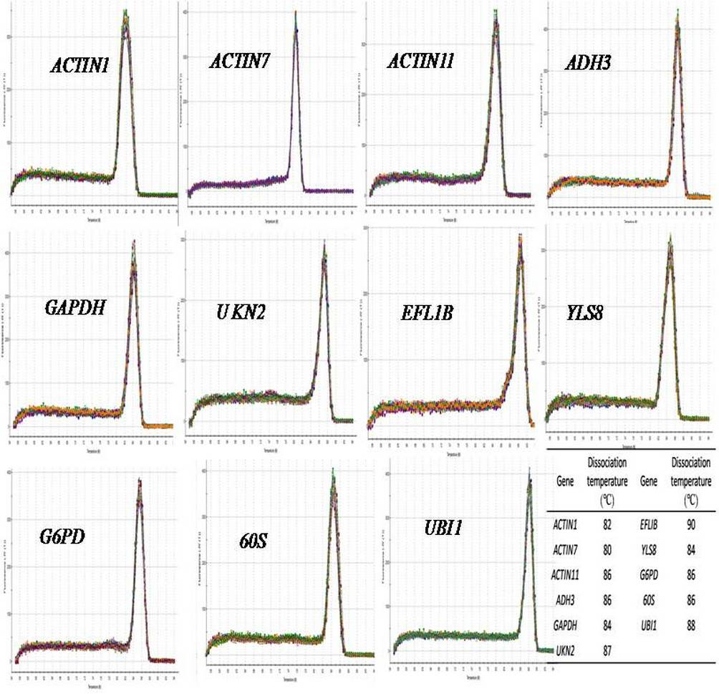

**Figure S1 Dissociation curve and temperature of candidate reference genes.**

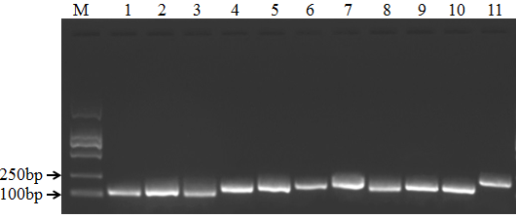

**Figure S2 Agarose electrophoresis analysis of the PCR products of eleven reference genes in peanut.** M: DL2000 Marker; 1-11：*ACTIN11*, *ACTIN7*, *ACTIN1*, *ADH3*, *GAPDH*, *UKN2*, *EFL1B*, *YLS8*, *G6PD*, *60S*, *UBI1*