Table 1. Description of native potato collection
Laboratory number | Accession | Name | Geographic origin
1 | UCT-11Mgb | Meca gato blanca | Chiloe Island
2 | UCT-14MgRe | Redonda | Chiloe Island
3 | UCT-17Br | Bruja | Quinchao Island
4 | UCT- 6Gc | Guadacho colorado | Chonchi, Chiloe
5 | UCT-24Tn | Tonta | Castro, Chiloe.
6 | UCT-22Cm | Clavela morada | Castro, Chiloe
7 | UCT-25Gñ | Guicoña | Quellón, Chiloe
8 | UCT- 7Ca | Camota | Chiloe Island
9 | UCT-18Mn | Michuñe negro | Chiloe Island
10 | UCT-26Ach | Azul chañihue | Chiloe Island
11 | UCT-27Mu | Murta | Quellón, Chiloe
12 | UCT-28MiR | Michuñe rojo | Chiloe Island
13 | UCT-29Mol | Molejona | Chiloe Island
14 | UCT- 3Cl | Clavela | Los Muermos, Chilean Mainland
15 | UCT- 1Ma | Michuñe azul | Chiloe Island
16 | UCT-16At | Azul table | Chiloe Island
17 | UCT-30Ño | Ñocha | Chiloe Island
18 | UCT-19Aq | Azul de quento | Castro, Chiloe
19 | UCT- 2Lv | Lengua | Castro, Chiloe
20 | UTC-31Ob | Ojitos blanco | Ancud, Chiloe.
21 | UCT-32Ci | Cielito | Castro, Chiloe
22 | UCT-20Ro | Rosada | Chiloe Island
23 | UCT-33Cab | Cabrita | Chiloe Island
24 | UCT-15MgRo | Meca gato rojo | Chiloe Island
25 | UCT-21Ac | Azul cristalina | Chiloe Island
26 | UCT-34Cor | Cordillera | Castro, Chiloe
27 | UCT-35AzC | Azul caucheque | Castro, Chiloe
28 | UCT- 8Gb | Guadacho blanco | Ancud, Chiloe
29 | UCT- 9MgM | Meca gato morada | Ancud, Chiloe
30 | UCT-10MgL | Meca gato morada larga | Los Muermos, Chilean Mainland
40 | Sf | S. fernandezianum | Juan Fernandez Archipelago

Table 2. Description of commercial cultivars
Laboratory number | Name | Geographic origin | Year of release | Parents
31 | Desirée | Introduced Cultivar ZPC-Holland | 1962 | Urgenta x Despeche
32 | Karú | Chilean Cultivar | 2002 | Yagana x Fanfare
33 | Shepody | Introduced Cultivar Canada | 1980 | Bake-King x F58050
34 | Baraka | Introduced Cultivar | -- | SVP 50-358 x Avenir
35 | Híbrida | Hybrid LT8 xTS-9 | -- | LT-8 x TS-9
36 | Rosara | Introduced Cultivar Solana-Germany | 1990 | Secura x 2605 77
37 | Yagana | Chilean Cultivar | 1983 | Hydra x 904/61
38 | Pukará | Chilean Cultivar | 1993 | Cleopatra x Yagana
39 | Rodeo | Introduced Cultivar | -- | --

Table 3. General description of SSRs used in genetic characterization of the potato collection
Locus | Repeat motif | Approximate fragment size (bp) | N° of alleles | Polymorphism information contend | Power discrimination | Primer sequences forward (F) and reverse (R.) | Source
SSR1 | (TCAC)_{n} | 230-194 | 11 | -- | 0.91 | F.5´GATGAGATGAGATATGAAACAACG3´  R.5´GCAATTTCTCTTGACACGTGTCACTGAAAC3´ | Moisan-Thiery et al. (2005)
STM2005 | (CTGTTG) | 193-160 | 5 | -- | 0.79 | F.5´TTTAAGTTCTCAGTTCTGCAGGG3´  R.5´GTCATAAACCTTTACCATTGCTGGG3´ | Moisan-Thiery et al. (2005)
LEMALX | ^{n}(ATT)_{n} | 140-120 | 4 | -- | 0.84 | F.5´CTCACCCACAAAGAAAATTC3´  R.5´CTAACAAACATTGTACAACAATAATC3´ | Moisan-Thiery et al. (2005)
STM1097 | (CGTTT)_{n} | 281-234 | 6 | -- | 0.82 | F.5´GTTCACAGCCTTCGTGAACG3´  R.5´ATTCAAACTCAGCCAGCAGC3´ | Moisan-Thiery et al. (2005)
STM2020 | (TAA)_{n} | 193-160 | 10 | -- | -- | F.5´CCTTCCCCTTAAATACAATAACCC3´  R.5´CATGGAGAAGTGAAAACGTCTG3´ | Moisan-Thiery et al. (2005)
STG0016 | (AGA)_{n} | 137-174 | 14 | 0.773 | -- | F.5´AGCTGCTCAGCATCAAGAGA3´  R.5´ACCACCTCAGGCACTTCATC3´ | Ghislain et al. (2009b)
STI0030 | (ATT)_{n} | 94-137 | 17 | 0.811 | -- | F.5´TTGACCCTCCAACTATAGATTCTTC3´  R.5´TGACAACTTTAAAGCATATGTCAGC3´ | Ghislain et al. (2009b)

Table 4. Total and average number of alleles, percentage of total number and exclusive alleles
Species | Total allele number | Average allele number | Percentage of total | Exclusive alleles | Percentage of exclusive alleles
S. tuberosum ssp. tuberosum | -- | -- | -- | -- | --
Native varieties | 57 | 8.14 | 89.0 | 21.0 | 33.0
Commercial cultivars | 39 | 5.57 | 60.9 | 5.0 | 8.0
S. fernandezianum | 8 | 1.60 | 12.5 | 4.0 | 6.3

Table 5. Number of alleles per locus
SSR locus | Total alleles | S. tuberosum spp. tuberosum |  | S. fernandezianum | Approximate fragment size (bp)
SSR locus | Total alleles | Native varieties | Commercial cultivars | S. fernandezianum | Approximate fragment size (bp)
STM 2020 | 6 | 5 | 4 | 1 | 160-140
SSR 1 | 8 | 8 | 5 | -- | 220-172
STM 2005 | 12 | 9 | 7 | 2 | 193-110
LEMALX | 12 | 10 | 7 | 2 | 140-118
STM 1097 | 5 | 5 | 3 | -- | 280-224
STG 0016 | 12 | 12 | 7 | 1 | 166-125
STI 0030 | 8 | 8 | 6 | 2 | 112-85

Table 6. Polymorphic information content
Locus | Repeat motif | Polymorphic information content
STM2020 | (TAA) | 0.76
SSR1 | (TCAC) | 0.77
STM2005 | (CTGTTG) | 0.78
LEMALX | (ATT) | 0.87
STM1097 | (CGTTT) | 0.63
STG0016 | (AGA) | 0.89
STG0030 | (ATT) | 0.83

Table 7. Polymorphic information content at seven microsatellites markers for native varieties and commercial cultivars.
Material groups | STM 2020 | SSR1 | STM 2005 | LEMALX | STM 1097 | STG 0016 | STI 0030 | Average
Native varieties | 0.70 | 0.79 | 0.77 | 0.86 | 0.66 | 0.87 | 0.81 | 0.78
Commercial cultivars | 0.68 | 0.68 | 0.68 | 0.79 | 0.44 | 0.80 | 0.77 | 0.69

Fig. 1 Allelic frequency for S. tubersum ssp. tuberosum and S. fernandezianum for loci (a) STM 2020, (b) SS R1, (c) STM 2005, (d) LEMALX, (e) STM 1097, (f) STG 0016 and (g) STI 0030.

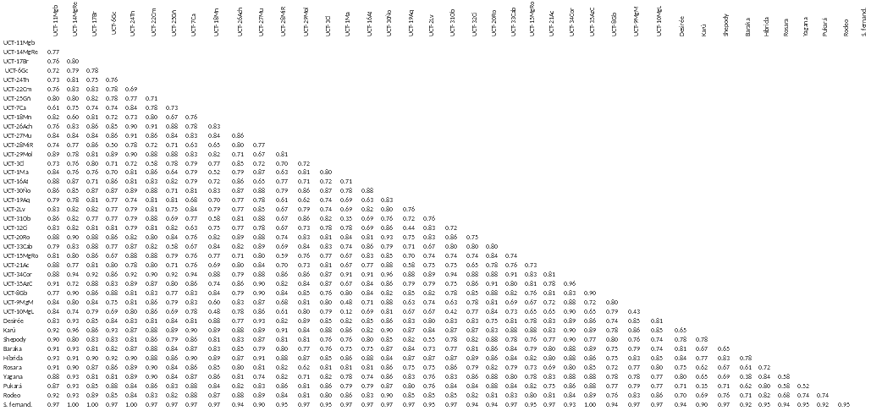
Fig. 2 Dissimilarity matrix using Sokal and Sneath 2 coefficient calculated with DARwin 5.0 program.

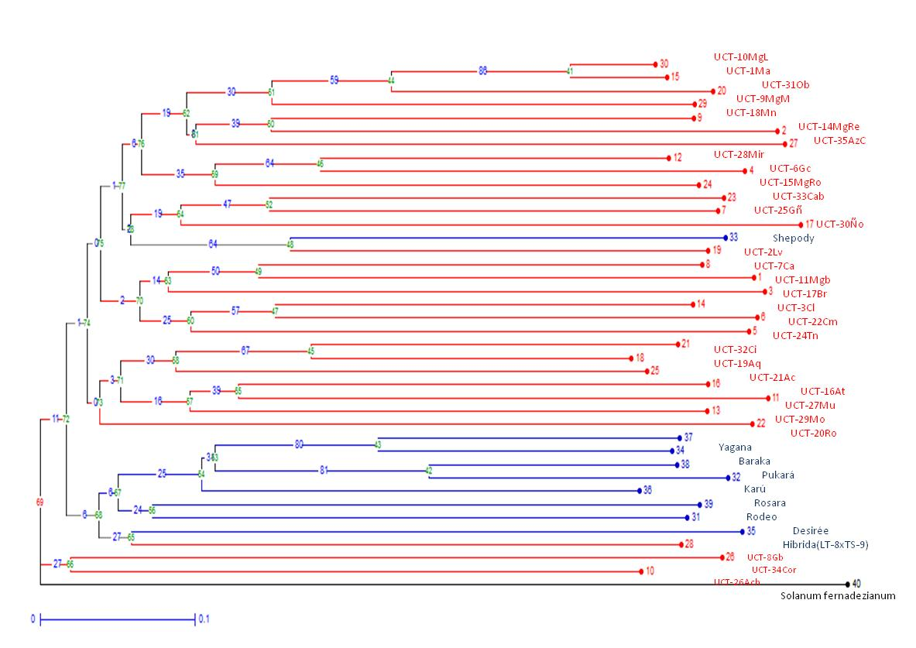
Fig. 3 Rooted dendrogram of native varieties, commercial cultivars and S. fernandezianum product of the allelic variation of seven microsatellite markers.

